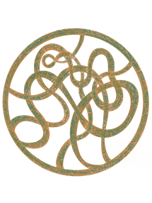

|Norse Notes|

This story deals with concepts and elements mainly derived from Norse Mythology. Think of it as a saga that was lost over the years. The Norse Pantheon has always brought such interest and curiosity to my mind, and the stories of the Eddas have journeys to satisfy any type of reader. My intent with this story is simple: to create a short yet exciting read for everyone who enjoys a good battle. Hopefully it proves to be worthy enough to sit amongst the other Norse texts on everyone’s bookshelves.
The culture of people that held beliefs of the Norse gods are popularly known as the Vikings. Christianity had distributed itself throughout what is now known as England. The Vikings, much like the Anglo-Saxons a few centuries prior, worshipped different Gods and Goddess’s and decided to visit the new lands for themselves.
Old Norse is the language of the Vikings. This story has a few different spots where it is used to emphasize authenticity. The phrases used in the text are created by me, using reconstructed Old Norse. Refer to the back of the book for the resources used while learning this language. Word order is more open in Old Norse than that of English, so please consider this if you choose to compare the phrases side by side.
A berserker is a particular type of warrior usually depicted wearing a bearskin coat with the head acting as a hood, and paired with their greatness in size, takes on the image and properties of a bear. The phrase “going berserk” comes from the Old Norse term berserkr meaning “bear-coat” or “wild warrior”. From our sources, we know that berserkers served as bodyguards and/or champions for kings and acted as lone warriors attempting to conquer wherever they walked.
Much like the berserkers taking on the form of the bear, there was another, not as known, group of Vikings that subscribed to the form of the wolf. Known as the Úlfheðnar, from the Old Norse term translating to “wolf coats “, they traveled in packs and portrayed themselves as wolves by running on all fours and howling to the moon.
In Norse Mythology, the God of Thunder, Þórr (Thor), can be thought of as a sort of berserker, with his short temper and powerful hammer, he has the ability to overcome whatever threats present themselves. Þórr usually never needs assistance fighting while in his mad state of mind, so, compare this to a bear filled with rage.
Wolves and ravens are symbols of the God of Wisdom, Óðinn (Odin). He has two wolves at his side, and two ravens on his shoulders. The wolves eat his food, and the ravens are responsible for his memory and thoughts. It is believed that the Úlfheðnar devote themselves to Óðinn, and in return, they are essentially guaranteed victory, being given the immunity to fire and steel, both common elements found throughout a field of battle.
It should also be noted that Fenrir, the original ‘bad wolf’ and a child of the Trickster God Loki, was chained up by the gods until breaking loose to fulfill his destiny at Ragnarök, “the world’s doom”. Some argue that this could be the driving force behind the Úlfheðnar, they simply break free and destroy.

To my dog, Oden.

For a bear can only be poked so many times.

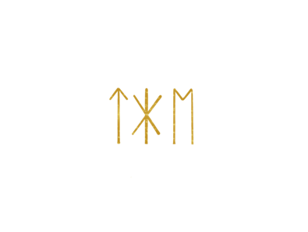
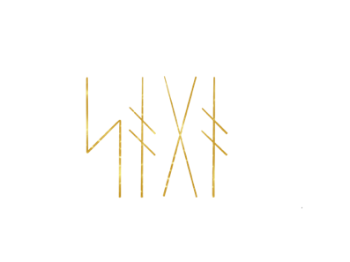
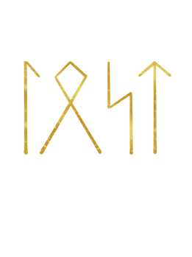

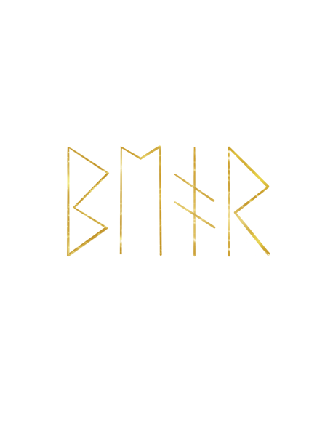

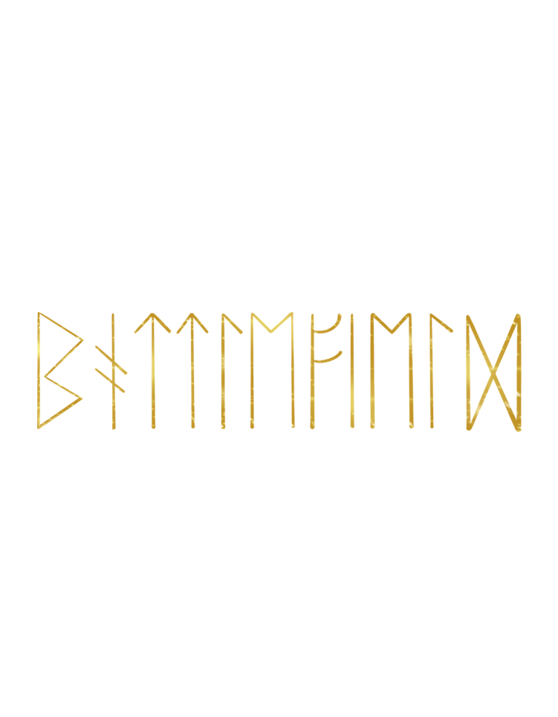

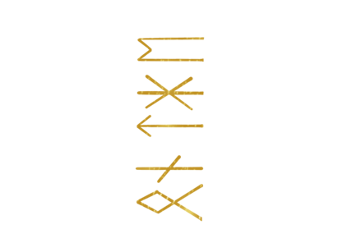

The Lost Saga
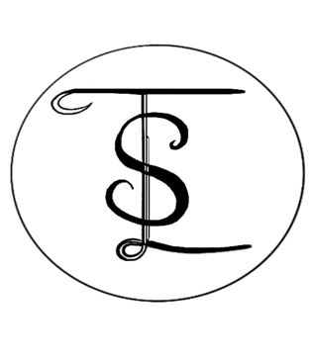

Bear

on the

Battlefield

In the middle of the woods lies a wounded warrior. A large horse speeding by had knocked him unconscious. In this realm of dreams and thoughts, he now drifts along on the eight-legged steed. Memories of his brother, of his mother and father, now dead, begin to haunt him. Glimpses of war loop through his mind, each time ending with screams and fire. If it wasn’t for the Great King of the Land, his family would still be alive.
This warrior’s name is Hoárm Biflindi, and he’s determined to show the king to the rest of himself. A raid from the men of the cross on heathen territory left quite a site. Smoke from the fires clogged the air. Bodies were left bloodied, some still in their beds. Other than the crackling of burning wood, it was all too quiet. Hoárm had just returned from the east. In his ship, filled with spoils from the journey, he finally caught site of the coastline. His family and people were living just north of the coast. As the boat continued closer, Hoárm noticed the dark smoke, not really thinking anything of it. With the help from a few other warriors, the silver and weapons were gathered to bring back to their camp. The smoke seemed to be coming from somewhere close though. It started to become unsettling for the warriors who picked up the pace and made their way home.
What they returned to was nothing short of chaos and destruction. Not one person was left alive to tell of what happened here. Hoárm threw his handful of items down and rushed to his tent. At the front entrance laid a body with a sword still in hand. He started to fluster his words and began to weep. Surely, he knew who this was, but he didn’t want it to be true. This was the body of his brother, and it was more than apparent that he was attacked. ‘Who would do this?’ Hoárm spoke and made his way into the tent. He stepped inside and immediately froze. His mother and father had looked to be butchered, together. Both hanging and naked, they had their backs carved into. The symbol left behind was a cross that stretched from head to pelvic and ran shoulder to shoulder. Hoárm fell to his knees. His earlier weeping was now starting to sound like growls.
The same sounds were coming from across the camp. The other warriors experienced loss as well. Most of them, middle-aged, with brothers and sisters, were now alone. After some time, it started to sink in that everyone left at the camp are now the last of their families. If Hoárm didn’t leave to raid, there’s a good chance the warriors would all be dead too. The cries and screams of agony continued. Hoárm and his warriors all gathered around the middle of the camp. It was open in the middle with trees offering a somewhat circle-like border. The group gathered what was left of their families along with their silver and weapons.
Hoárm stepped into the middle of the orange coals that filled the area for fire. With his bare hands he began to dig. Clumps of ash and dirt were thrown, and the hole continued to get deeper. Finally, something silver began to reveal itself. He dug a bit more until the silver object could be grabbed. It was long and rectangular and had symbols carved neatly all over it. It was a chest, but with what inside of it? And why was it hidden underneath the earth and heat? While Hoárm was digging to bring the chest up from the hole, the other warriors started to beat their chests and chant in place, yelling “HOO! HOO! HOO!”
Hoárm ran his fingers across the symbols on the chest. The chanting of the other warriors carried on, with each time louder than the last. Finally, the chest was cracked open. Hoárm reached inside and started handing out big bundles of fur. Each warrior was handed a piece as they nodded in acceptance and continued to chant. The fur was folded and had the head of a wolf attached and sitting on top. They held onto the wolf coats given, and Hoárm himself grabbed the last of the fur, the one that rested in the bottom of the chest. This was the fur coat of a great grizzly bear, and it had been quite a long time since it had last seen battle.
The families of the warriors and their belongings were set appropriately, side by side, atop the heated coals. From the fabrics of those with clothing, the heat turned to flame and traveled up the bodies. The flames started to rise, and the camp of warriors dressed themselves in the furs of the animals from the chest. Their actions and mannerisms started changing once the coats were placed over their armor. No longer were these warriors, men, but animals ready for war. They beat their shields with their weapons and started the hunt for the men of the cross.
Laying on the green terrain, Hoárm could feel himself riding back towards consciousness, for it had only been a few moments. A high-pitched ring left his ears and his one and only eye began flickering. Finally awake and looking to the sky, shades of blue and orange mix together, and thick, gray clouds continue to linger low. His eye followed a raven circling high above the trees. This, he knew, was a sign from the Raven-God himself. He continued breathing slowly and ran his fingers through the dirt beside him. Drawing an ‘X’ over his missing eye with the dirt, he spoke the rune ‘gebo’, meaning gift, and instantly, he went from ground to sky, connecting with the charcoal-colored bird through its sight. This was a tactic deployed to be a step ahead of the enemy. When Hoárm is linked with the raven, he can see what it sees, giving him time to prepare and understand what he is up against. He saw the tops of the trees, the field of metal that was just ahead, and the towering stone stature of the king’s castle. The link between him and the bird spontaneously ended as he saw what he needed to see. Rolling over, he rose and shook himself into a rage. Picking up his ax, and having hammer in hand, he proceeded through the woods chanting, “Til dauði goð konungr!”, meaning ‘Death to God’s king!’.
He passed trees of varying size with branches tied into symbols that offered eternal life and protection. Other symbols had been etched into the bark, some curvy, and some rather straight. The straighter markings seemed familiar, with some of the same symbols carved into his skin and weapons. Remnants of rope from certain trees still hang yet the bodies once attached are long gone. With the mind of a beast and filled with rage, the warrior continued towards the sounds of clanking metal and howling wolves.
Breaching the edge of the woods, the bear-like-being was meant with guards and spears. The three men of the king drew their weapons, ready to charge the warrior, yet their moment had already passed. Hoárm’s ax gained momentum from its release until it found a new resting place in the chest of one of the soldiers. Stricken by the look of this warrior, and even more by the size of his hammer, the guards took a big gulp and darted forward with spears. One of them missed while the other was caught by the grizzly. Yanking the weapon with power, the soldier’s head had been met with a vicious backswing from the hammer. The soldier's body met the ground and his head saw high above the clouds.
The other spear-wielder stood in shock. Wasting no time, the bear plunged his shoulder into the soldier’s torso, giving him a mouth full of fur and a loss of balance. Still holding the spear that was supposed to stick him, Hoárm threw it at the stumbling meatsuit. The metal-tipped weapon met first the air, followed by flesh, and ultimately the dirt, leaving the soldier angled for the high heavens to see. Retrieving his ax, the bear headed for the castle walls. He was vengeful in his walk, and just waiting to break apart anything that dared to cross his path. His men, wreaking havoc on those in favor of the king, have embraced the form and powers of the wolf. Sharp teeth and claws, and all of the terrifying sounds helped to convince their opponents that they were fighting no ordinary men. The wolves ran on all four legs when needed with their hands and feet throwing dirt up in every direction.
Clearing a path for the bear on the battlefield, the wolves worked as one to rip through the oncoming enemies. Some of the guards were highly armored, larger in size, and seemed to know, well, the art of sword-skill. This was no matter. The wild dogs were unintimidated. For they were the ones to inflict fear. They would open their mouths wide to the sky allowing for their pointy teeth to be shown. The lack of weapons mixed with their unstoppable energy made them appear all the more fearless. Flaming arrows were fired, spears, thrown to kill, but nothing could touch the warriors of the north. Hoárm was almost to the gates of the castle. He saw them being forced shut by the guards from inside. The wolves however found themselves occupied with a larger soldier wrapped in metal fittings. On his back and chest shone a great, golden cross. Many just like him were placed throughout the land, so the armor was quite recognizable. They circled around the guard, all eager to make an attack. The magnificent man in metal started to swing his great sword, yet the wolves moved closer and closer. They kept low to the ground to avoid being pierced, but the guard knew how to handle his weapon. Complications arose but only quite briefly. They growled and showed their teeth and had foam dripping from their lips. They teased the guard by lashing forward to bite the air in front of them.
The guard, with his weapon pointed to the Almighty, started to tremble. He was continuously spinning around, uncertain of where to set his eyes. Everywhere he looked, he saw his men, scattered and lifeless, throughout the open field. Does this soldier know that he is about to die? And if so, is he proud of the side he chose to be on, with the decisions he has made in this life? The bear looked over his shoulder and saw his dogs playing with their food. The raven from before was now flying above the soldier that was trapped in a circle of wolves. The clouds continued to distribute themselves until the sun was officially absent. The area over the guard became dark, and as he looked up at the bird, the wolves made their attack. A quick distraction was all that was needed for them to overtake the man in metal. He was trampled over by the wolves from behind and was torn apart in the directions of his golden cross. The guard was left in five pieces with scratches and bite marks throughout his armor.
The bear gained speed. He was now at the gates of the castle. Plunging his hammer straight, the doors had closed as much as they could with the squared weapon squeezed in-between them. Thunder itself had approached as the warrior gave the door a great kick. He sent it back wide open and grabbed his hammer before it fell to the ground. Once inside the stone enclosure, the swing of an ax from knee to nose was the fate of the first guard. Another Kingsman took a chance with his spear, attempting to hit the raged animal in his side. But Hoárm was too quick and shifted his weight, redirecting the spear into the guard at his left.
The gray clouds started singing songs of storms and he threw his hands up to let out a great roar. He took a step towards the guard which overwhelmed the man of gold, and he fell onto his back. The blur of brown fur filled the eyeholes of the guard’s helmet as the warrior stood over him snarling. He tried to make out the face that was in the mouth of the bear to be reminded that this was just a man. However, the characteristics of the beast were showcased so well that he couldn’t convince himself in time.
Raising the hammer well above his head, Hoárm looked to the sky and felt rain trail down his face. Lightning shot across the earth and briefly connected with the beast. He looked back down and threw his hammer at the head of the guard below him. The face of the helmet dented inwards, and what was gold quickly turned to red. Everyone around was cowering in fear, and those who couldn’t hide ran in every direction that the bear was not. Paying them no attention, he kept his eye looking straight and his mind on the king.
The wolves found every way to enter the fortress. They climbed the little shacks built outside and around the castle. They jumped over the stone walls that failed to protect the innocents inside. The bear, though, moved through the marketplace. He stopped his feet in front of a large stone cross with artistic swirls and a stone base. This was a place for worship as one could tell from the three stone benches placed around the sacred symbol. They were very intricate in design. Each one had delicate swirl patterns and pieces of scripture written in a romantic looking language. Stepping behind the cross, he shoved into it until it began to fall. And it did fall and resulted in dust and pieces. The craftsmanship that went into the creating of this object was, like a lot of things, unfortunately, overlooked, and ultimately turned to ruin. Hoárm cared not about the detail, only that the symbol belonged to a belief, that he himself did not believe. “Til dauði goð konungr!” he stated and gathered himself before entering the tallest part of the castle.
These doors opened rather easily to a long, candle lit hallway filled with colorful tapestries. The ornate fabrics told of the victorious battles led by this land’s king. With the claws from the bear’s paw, he ripped through the fabric and continued down the gleaming walkway. Down at the end stood a group of guards in front of a grand door. They clinched together and collected themselves waiting for the bear to march. Behind the warrior entered another group of guards. They shut and barred the doors behind them. Clearly Hoárm was outnumbered. There was only one thing that he could do to get out of this mess… He had to summon the power of the Giant-Slaying God. He shut his eye, gripped his weapons, and whispered the following phrase: “Ek em fúll. Ek em bani. Ek em vegr”, meaning ‘I am foul. I am death. I am glory.’
The mystic symbols carved into his arms and chest began to glow blue. Little bursts of lightning started to spark from the symbols and traveled down both of his arms. More and more, the blue lines of energy became consistent. The guards now looked worried and tightened their formation. Hoárm looked up and quickly hurled his hammer down to those guarding what was seemingly the king’s quarters. The hammer hit hard and left a guard pinned to the door. The others were struck by the lightning protruding from the weapon. The bear turned around to meet the other guards with madness. He broke the long wooden weapons with the swings of his ax and continued to eat space between him and his enemies. There were only a few alive now.
In the midst of his swinging, Hoárm reached his other arm out in the direction of the hammer. It was still holding the guard to the door until it suddenly stopped and let his body be with the others. The weapon traveled back with great speed however the bear bent down at the last second, having it strike the guards still standing in a zigzag fashion. It then returned to his hand. He took a quick look around; no one was standing but him. Hoárm then repeated his mantra “Til dauði goð konungr!” as he thudded and kicked his way through the obstacles on the ground. The door with a colossal golden cross in its center, accompanied by golden inscriptions that ran along the edges and with an overwhelmingly thick, metal-ringed handle sat at the end of the hall. For this was the only thing now between the bear and the king.
A hard pull on the metal ring of the door, but it would not budge. Hoárm stepped back, dropped his ax in his belt loop, and with both hands, led a huge crash with his hammer into the center of the door. With the wood now cracked and the cross no longer whole, the beast continued to drive his hammer deeper and deeper until there were openings to the other side. Looking through a freshly made hole, he saw the king in pure distress, viciously pushing his wife, the queen, and their son down some sort of haven. Did this opening in the floor provide an escape? Could it possibly run all along but just underneath the castle walls? Maybe it was just an enclosure that would be resorted to while waiting for certain hardships to pass. The man with bear-spirit wasted no time entering the room. Hoárm walked hard and was breathing heavily, and not because he was out of breath, but because he had finally been met with his goal, now only fifteen feet in front of him.
The king dropped the square-caged door with it latching and locking behind itself. Immediately, his royalty begged for mercy from the grizzly that had just taken his castle. Like a fish jumping out of water, he knew he had been captured, and continued to back away with both hands in surrender. Wolves entered from behind just as Hoárm had kicked the king. They flipped over the tables covered with food and drink and set flame to whatever would burn. Making one last attempt to save his own life, the king turned around and planted a dagger in the stomach of the bear. Hoárm looked down to see this for himself, and the king crawled away while he still could. Storms continued heavily and the king’s quarters turned dark. Hoárm relieved himself of the weapon that almost slid through the bear coat. The blade hitting the stone floor complimented the beating rain on the windows and added to the king’s paranoia. He knew he was in a cage with animals, hungry animals that needed to eat soon.
Hoárm was now growling and showing his teeth to the current crown-wearer. Picked up from his feet, the king was in the hands of the bear now, and together they inched closer to the throne of power. The king pleaded and resisted uncontrollably. The latch for the door on the floor was broken so the wolves could scour the terrain below. Four of them jumped straight down disregarding the built-in ladder, and their scent was set on the other members of the royal house. Extreme force from above met the seat of the throne below as the body of the king was slammed down by the beast. He tuned out the sounds being made by his foe, showing no sympathy for the events that would follow. Hoárm snatched the great crown from atop the lord’s head. His hand was secured tightly around the throat of his enemy. He then thrust forward with the motion of a punch and threw the king’s head back into the top of the throne. This left him with eyes trying to find their way straight again.
Hoárm knelt to look the king dead in his rolling eyes. “Til dauði goð konungr!”, he said, and dropped his hammer. He followed with the slicing of his ax as it tunneled through the neck of God’s king. The bear snagged the upper piece of the king before it fell and found itself neighboring his hammer. Then he crossed the king’s arms, having his palms lay upright. The face of terror and regret was set down on one’s own lap where it would keep the permanent position of looking at what was once a king. With his mission now complete, Hoárm shoved his way back through the door, which was arguably his greatest opponent. He met back up with the howlers outside and together they walked into the woods. The battle was over, but the men remained animals. This was a mindset only for war. With the king now dead and too everyone who followed him, Hoárm and his warriors felt a sense of accomplishment, a sense of relief. For the members of their camp that no longer walk this earth, they have all been avenged and will never be forgotten. The traits of the bear, and of the wolf weighed heavily on those that take on their forms. To become mortal men again, they had to undergo a process, a certain ritual needded to be performed.
To start, they formed a circle and dropped their animal coats. The wind rushed through the trees and leaves began to fall. A dagger was passed around with each warrior opening a slit in their palm. The blade was then placed in the dirt, in the center of the circle.
They smeared a symbol across their face, a symbol of glory and restoration. From the left side of the chin, up to the right eye, they started. Then, up to the middle of the forehead. The marking continued down to the left eye and ended at the right side of the chin. Branches and tall grass were gathered around the dagger in the dirt. A fire was set, and everything burnt, and only the bloody blade remained in the earth. Through a break in the trees the warriors saw the raven that guided them through battle. The blackened bird divided itself in two and flew off in different directions. The warriors, drained of energy, took to the ground for rest. The next time that they awake, they will no longer behave like animals. As for the fortress and surrounding grounds, they too were left in blood and flames. To the other kings of the cross, this was simply a warning.

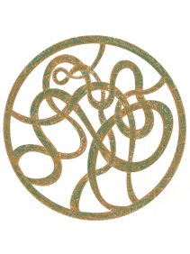

|Inspired Sources|

Arthur, Ross G. “English-Old Norse Dictionary.” York University, 2002, p. 13.

Cleasby, Richard and Gudbrand, Vigfusson. “An Icelandic-English Dictionary.” Oxford, 1874.

Crawford, Jackson. “The Poetic Edda: Stories of the Norse Gods and Heroes.” Hackett Publishing, March 2015.

Gaiman, Neil. “Norse Mythology”. W.W. Norton & Company, February 2017.

Morris, Marc. “The Anglo-Saxons: A History of the Beginnings of England: 410-1066.” Pegasus Books, May 2021

